FSM-PSO Integration Guide
  - A guide to the setup and functionality of the FSM-PSO integration

Contents
Introduction & Scope of Document 1
Overview of Functionality 2
Required Data Capture 2
Dataset Creation 2
Teams, Resources, Rosters & Shifts 2
Teams 2
Resources 3
Rosters & Shifts 4
The Scheduling Application Parameters 4
Communication 5
Business Rules 5
Business Rule 98 – Default Resource Type 5
Business Rule 99 – Configure Schedule Value 5
Value Mapping & Advanced Configuration 6
MPM’s 6
Scheduling Manager 7
Overnight Data Load 7
PSO Time Increment 8
Appointment Booking 8
Fringe Cases for Integrations Not Covered in Baseline 9
Troubleshooting 9
FAQs 9

Introduction & Scope of Document
This document steps through the functionality and configuration in both FSM and PSO that relates to the built-in integration to provide an understanding of the process and ensure a correct setup that makes the most of both systems as required by the specific customer requirements.
This document is not intended to cover the wider aspects of integrating FSM with 3rd Party applications. Information on more general FSM integrations can be found in the FSM Integration Documentation although some areas of FSM Connect are covered where it can assist with additional connections to PSO to facilitate more specialist forms of service.

The intended audience are any individuals that require assistance setting up or troubleshooting a FSM-PSO connection and should be used in conjunction with the other available FSM and PSO documentation.

The IFS Field Service Management Reference Guide (which can be found by searching for ‘Reference Guide’ in the FSM application menu) and the IFS PSO Administration Guide are recommended complimenting documents.

Overview of Functionality
The integration will perform an overnight load of all data that is required by PSO from FSM provided the relevant schedule has been created and is running (see the Overnight Data Load section of this document). This data is a one-off transfer so updates to the records in FSM are not included in this overnight transfer to PSO.
There is then a real time transfer of the day-to-day data e.g. tasks, shift status, technician location. This means that the mostly static data e.g. resources, shifts, skills is only updated on the overnight load once on creation and not real time or when updated.
The data sent is determined based on what is required for the PSO system to generate a schedule most befitting the customer’s requirements. Any data that would not improve the automatically generated schedule and is for information purposes only is kept only in FSM and FSM is the data master. This helps keep an efficient and fast connection between the FSM and PSO system.
Actions in PSO that trigger changes within FSM are travel planning (updates task travel time) and suggested dispatches (sets task to committed and updates the task assignee and planned start/end time).
Allocations and exceptions are sent back but make no changes in FSM to reduce system workload. The information is stored in the DSE_ALLOCATION and DSE_SCHEDULE_EXCEPTION FSM tables for review if required.

Required Data Capture
Some understanding of the intended tasks and scheduling requirements is needed prior to starting the integration setup. The necessary information should be contained within the Business Requirement Document.

The BRD should be used alongside this document to provide guidance on how the system needs to act in order to satisfy the needs of the customers business.

The sort of information needed would include:

- List of Task Types with schedule value, duration and skill (in line with "best practice template").

- Job volume assessment

- Server sizing analysis based on task types, BRD and job volume

- Determine what factors indicate positive results e.g. SLA adherence, reduced travel time etc

- PSO Server Sizing Analysis

Dataset Creation
There will need to be at least one dataset in PSO in order to use the FSM-PSO integration. Each dataset represents a self-contained schedule and multiple datasets are sometimes required depending on the details of the different schedules required. Analysis on how many datasets are required and how they are separated should be done prior to beginning the FSM-PSO setup. The PSO documentation will assist with this process.
Every dataset in PSO that is to be used by FSM for scheduling will need to be added to the Global Codes table THREESIXTY_DATASET_ID.

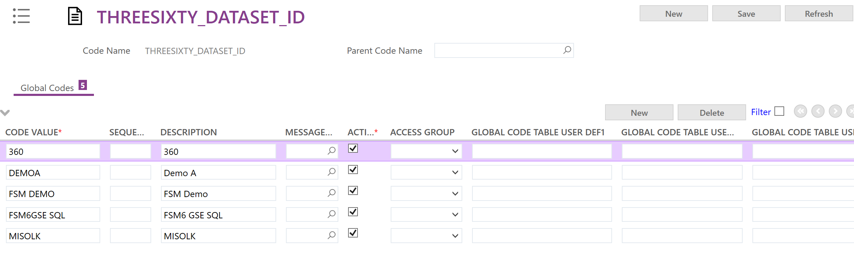

Teams, Resources, Rosters & Shifts

Teams

The FSM element that links to the PSO datasets are the Teams. Every team that will need to have tasks scheduled using PSO will need to have one and only one dataset associated with it.

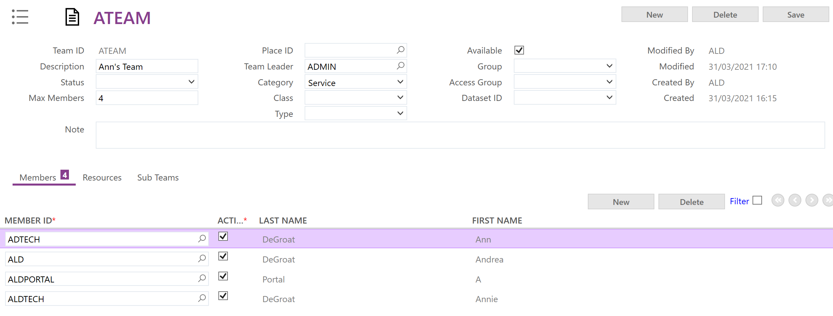

A person record can only be associated with one dataset. Take extra care to ensure that each person record is not placed into multiple Teams that relate to multiple datasets.

Resources
The process of creating resources in FSM involves a few steps. It is highly recommended to follow these steps in the defined order since transfer is a “transfer once” logic when the ARP is set to be in use.
If ARP is set to be in use then the resource should be maintained via the ARP in PSO after the initial setup. If ARP is not in use then the resource is maintained in FSM and the updates will transfer as part of the overnight data replication as long as there is one setup.
FSM should be used for resources where there is a simple set of needs for resources, ARP should be used where a more complex setup is required.

First, make sure that there are Place entries for the start and end points of each resource's working day. This may be from a depot or from the technician's home or some other designated location, but it must be set up in FSM with a default address record which contains valid geo location latitude and longitude values.

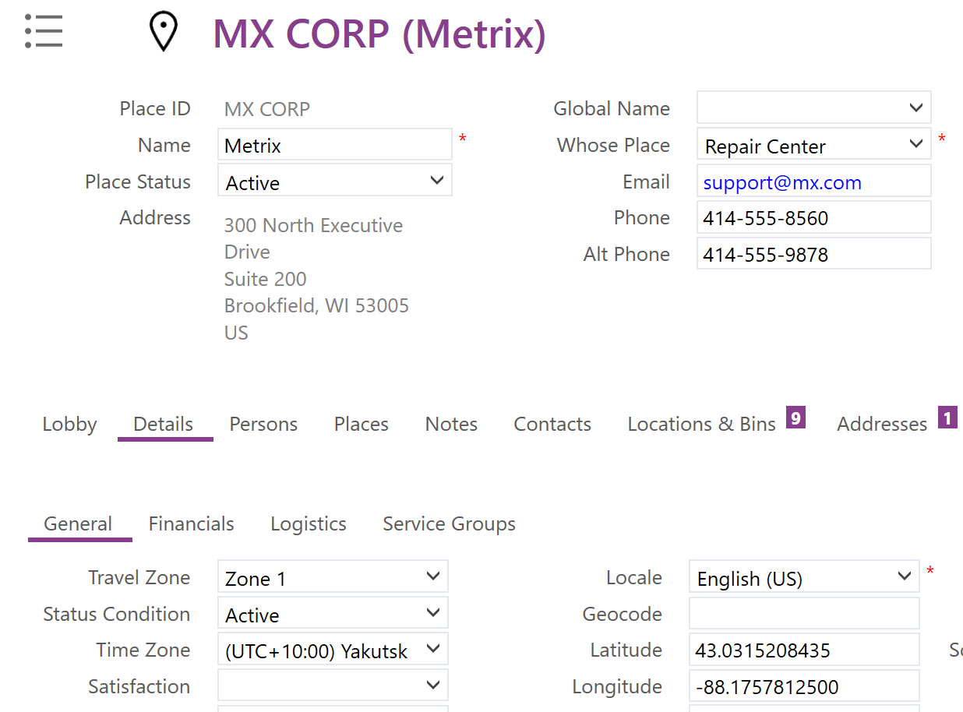

Once these are created you can add these to the Person record on the places tab as the “Starts Works From” and “Ends Work At” places.
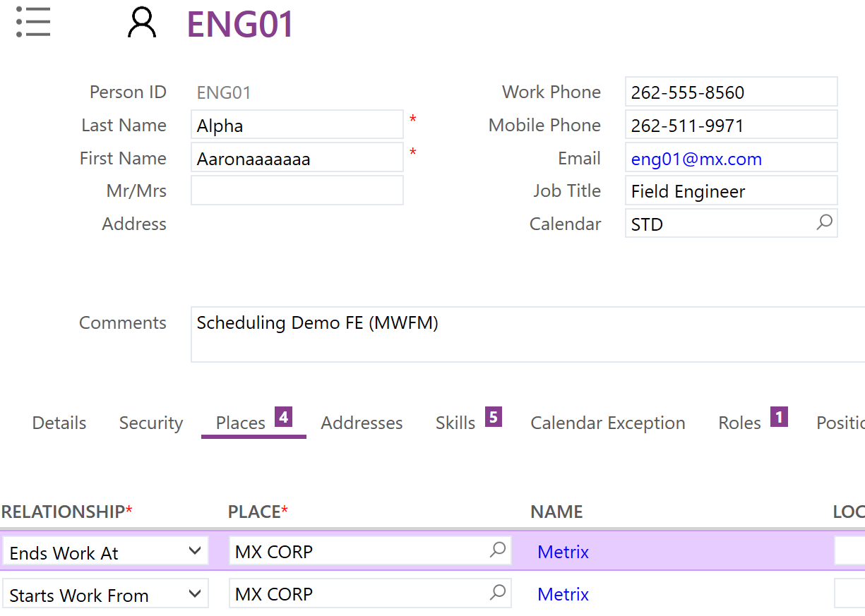

Next, on the details tab, set the dispatchable and scheduling resource flags on.

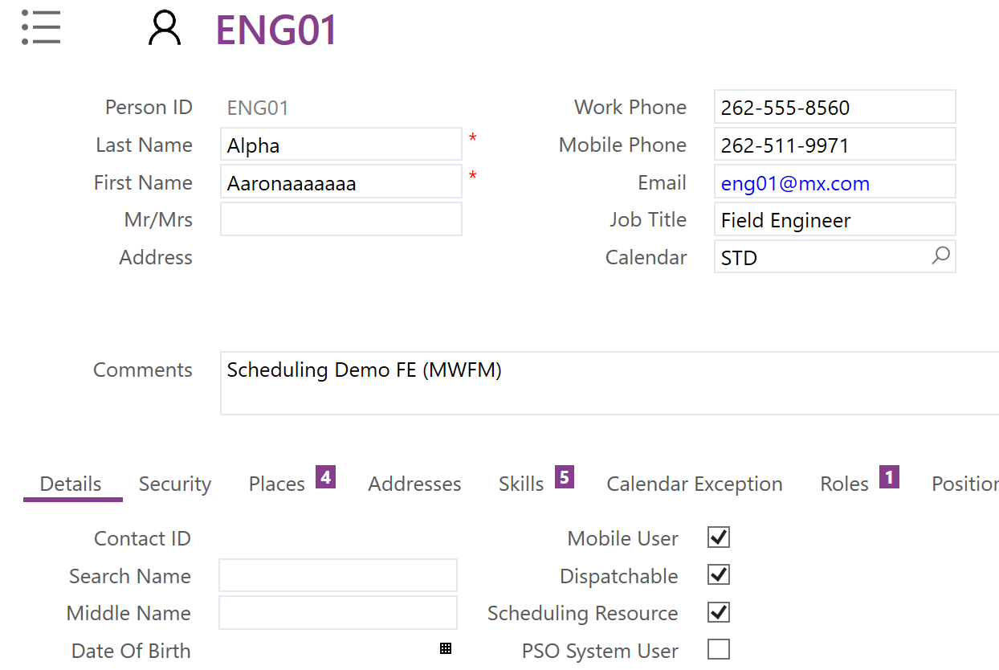

Once checked and saved, the scheduling resource flag will automatically create an entry with this Person records details as a Scheduling Resource.

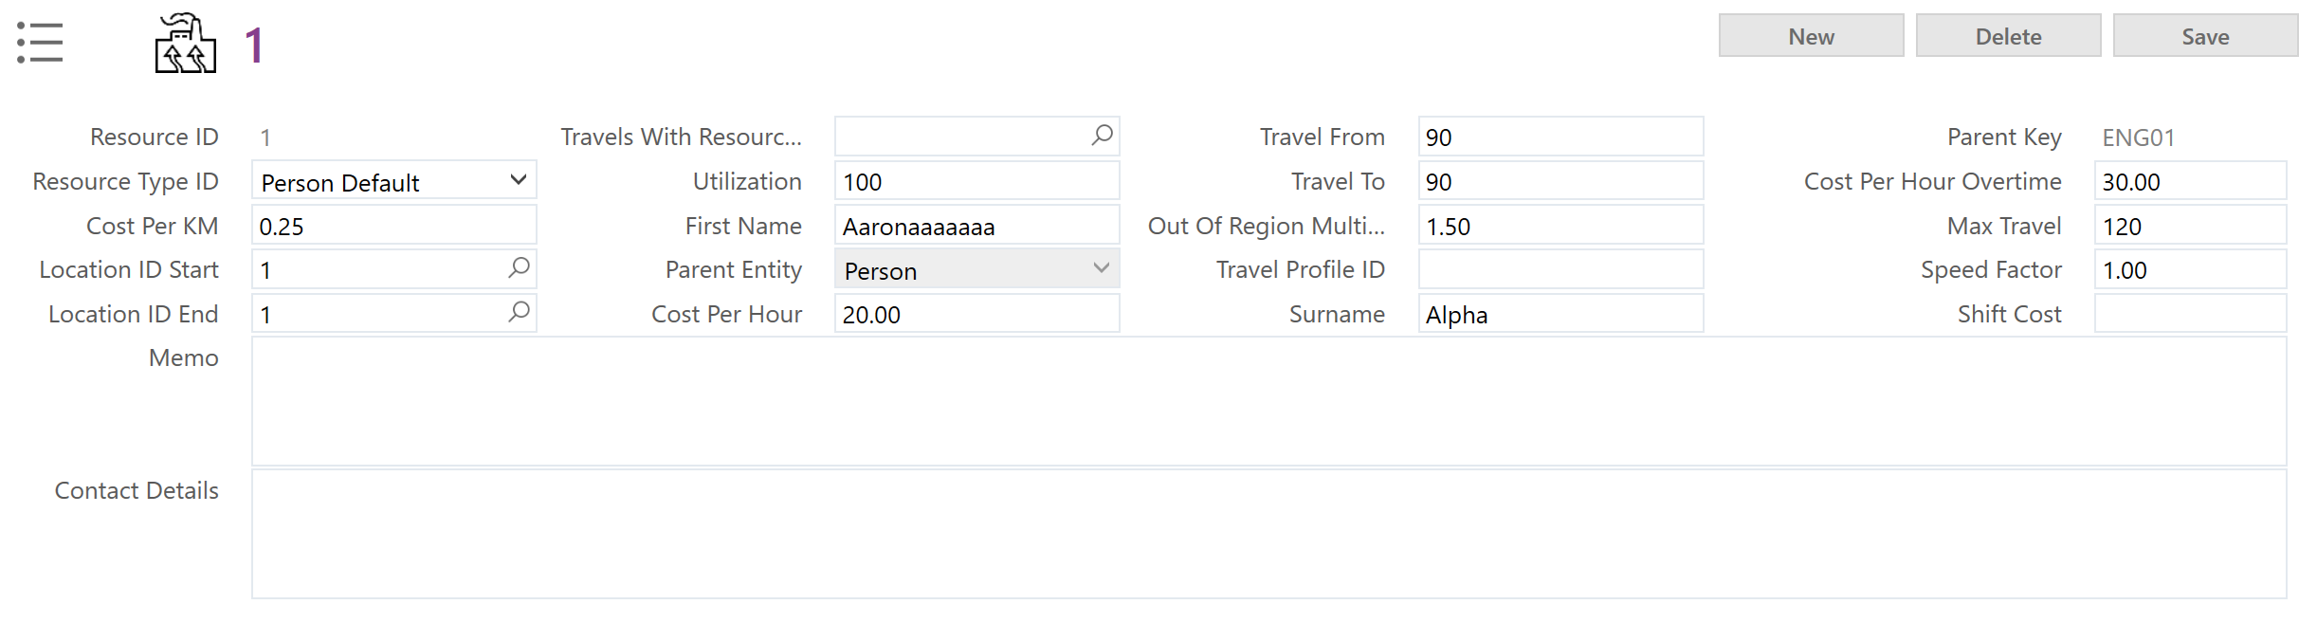

The resource type value brings in the different weightings and times for this type of resource.

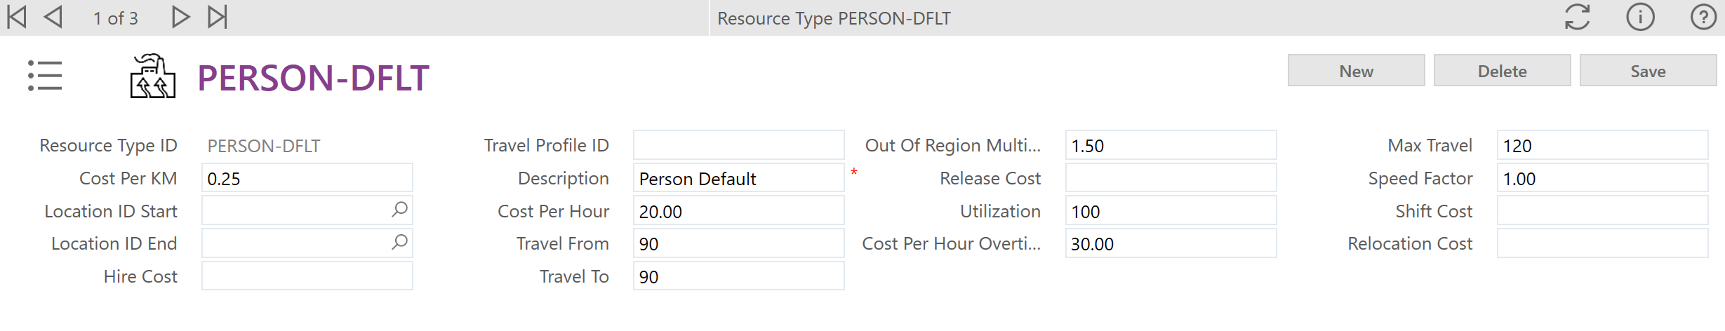

The business needs should be reviewed to determine if there are different types required e.g. do some technicians have higher costs per hour, do some start further from the region they work in etc.
If more types are required, they can be created as needed and once created they can be selected in the drop down for resource type ID on the scheduling resource record.

Next add the Person to the Members tab of the Team it is to be associated with so that they can manage any tasks from the mobile app and also add them as a resource on the Resources tab for the Team as this then ensures the resource is sent to the connected dataset.

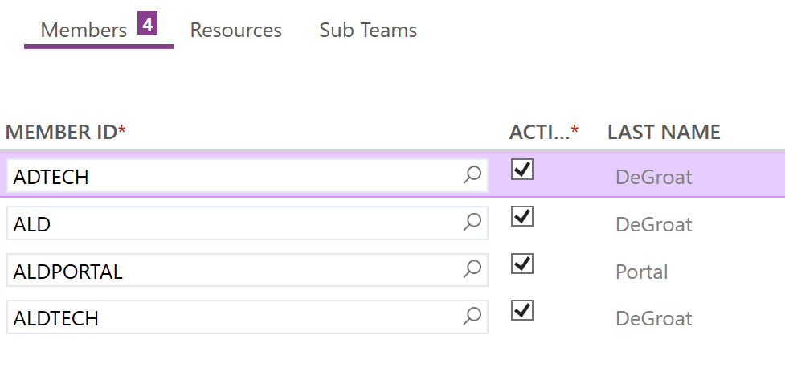
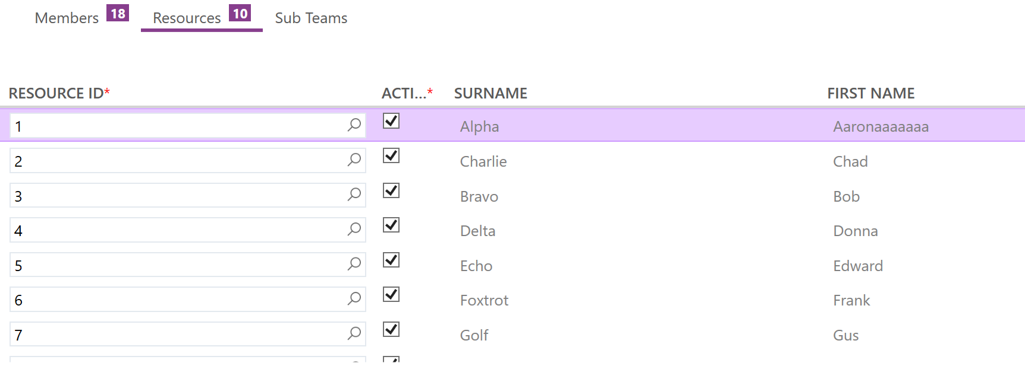

Note the member should use the Person record ID and the resource will use the ID from the scheduling resource record.

Rosters & Shifts

The shift patterns and calendar exceptions that are part of the FSM standard functionality will be sent over to PSO if they are generated against a Person set as a scheduling resource to the dataset against the Team they are a member of.
There is in app documentation to assist with this accessed by clicking the question mark at the top right in FSM when on the rosters screen.
This allows for simple use cases where there are standard shifts that do not change from week to week with just the odd holiday or absence that needs to be added.
For more complex shift pattern setups it may be better to use the ARP functionality within PSO to manage the availability of the resources.
If the ARP is selected for use instead then a rota will need to be set against the dataset to indicate which ARP rota should be used.

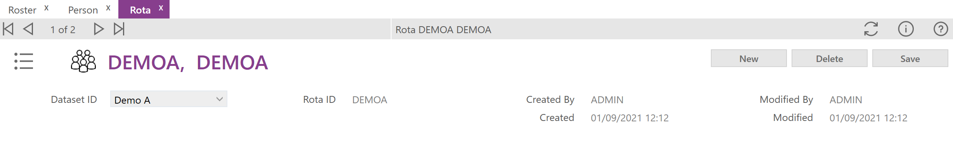
This is only required if ARP is being used to control the shifts. You can have multiple rotas against a single dataset so there is no requirement to stick to the one rota if more are needed.

You must ensure that one of these two options is performed and that the shifts are generated as this is how PSO will see availability for the resource.

The Scheduling Application Parameters
The scheduling integration has its own section of App Params that control and configure the scheduling functionality.
Each app param has a description that should explain its purpose and how it should be set. Each app param should be reviewed against the business needs and set appropriately.

Out of the box, all of the app params are set to be for all datasets but it is possible to have different app param settings for different datasets where there are multiple datasets in use with FSM.

The guidance for creating dataset specific app params is to leave the existing all datasets app param, click the new button on the scheduling app param screen and then fill in the fields to match the existing app param. The Dataset ID field can then be dropped down and changed from all datasets to whichever dataset this should apply to and the value set to whatever the desired value for this dataset is.

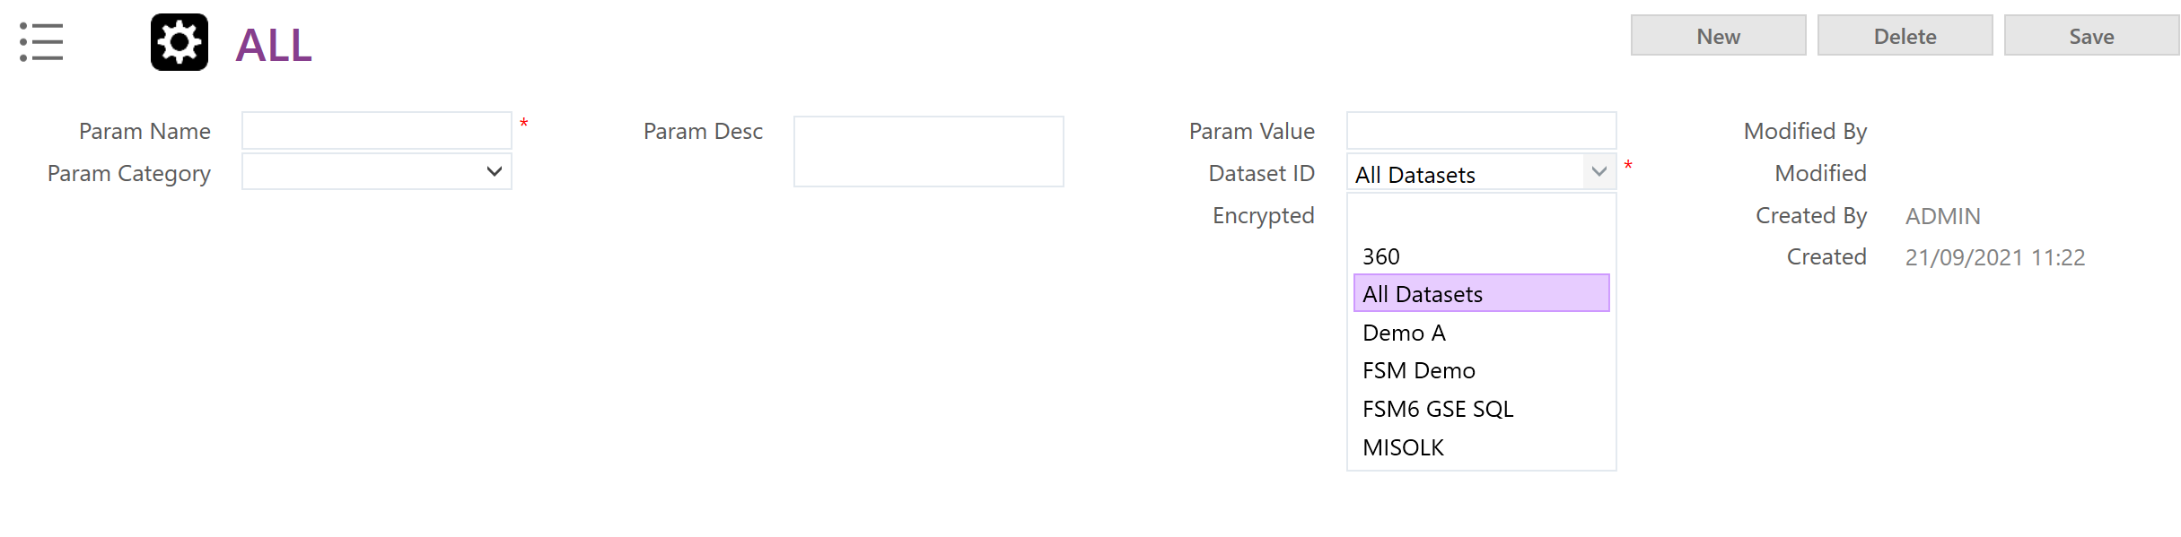
This way the ‘all datasets’ app param remains as a fall back in case no specific dataset entry can be found.
Do not amend the existing all dataset app param to be dataset specific. Always create a new, additional app param.

On a particular note, if the app param DSE_BROADCAST_ENABLED is set to Y, it would allow dynamic updates back to FSM of every change to the schedule as it occurs.

This now populates the DSE_ALLOCATION, DSE_PLAN_TRAVEL, and DSE_SCHEDULE_EXCEPTION tables instead of directly updating the tasks themselves but this can still result in massive impacts to overall system performance if frequency is not fine-tuned. As such, it is still heavily advised that the DSE broadcast remain disabled.

The currently planned schedule can always be viewed via the PSO schedule board and any manual changes made by users to the schedule in PSO are sent back with FSM being updated as a result so no targeted changes are missed.

Communication
Communication between FSM and PSO is done via web services.

The outbound XML should be sent to the PSO Gateway service which should be defined as part of the installation of FSM and are then stored in the web.config file in the FSM application folder structure, the username and password to use are setup in the scheduling app params.

To access the scheduling workbench from the FSM Web Client there will also need to be the relevant target URL added in the scheduling app param ISWB_WEBCLIENT. The user will also need to be marked as a PSO System User on their Person record.

PSO will send incoming XML to the endpoint declared in the app param BROADCAST_URL so this needs to be checked to ensure it is accurate and active.

PSO can also create direct links back to elements such as tasks in FSM from the schedule workbench as long as a valid URL for the FSM Web Client is added to the BASE_WEB_CLIENT_URL scheduling app param.

Business Rules
There are two FSM Business Rules that need to be noted for the FSM-PSO integration.

Business Rule 98 – Default Resource Type

As mentioned in the Resources section of this document, each PSO resource will need a resource type associated with it. Business Rule 98 is in place to serve this purpose.
Out of the box this rule will apply one of the default types based on what table triggered the creation of the resource e.g. a new Person record marked as resource comes from the Person table so it is assigned the Person-dflt type.
This business rule can be used to apply types in more complex situations if more types are available. Some differentiator between the types will need to be identified and then new rule conditions created to with that value as the input value and the relevant type as the output value. Check the Business Rule help in FSM for more guidance on creating and amending Business Rules.

Business Rule 99 – Configure Schedule Value

Business Rule 99 is how you convert the different task types and priorities in FSM to the scheduling value that PSO will use to prioritise different activities in its schedule.

Ensure that the scheduling app param for the default value is set so that if any tasks are missed by the other rules they do at least get some schedule value assigned.

The schedule values should have been captured earlier as noted in the required data section of this document along with their associated task types, priorities and any other factors.

This should then allow you to create rules to filter on the required factors and apply the appropriate schedule value. Example rules are in place out of the box to refer to for reference.

Value Mapping & Advanced Configuration
To ensure that FSM and PSO always show the correct task status in both systems the values for the PSO status and the FSM status must be mapped.
The FSM and PSO possible status values are held in FSM Codes under the Status and Schedule_status tables respectively. The Schedule_status values required should be already populated out of the box.

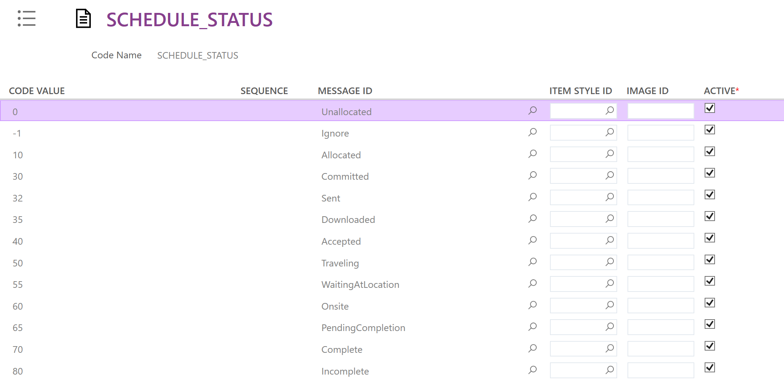

The Code Table Task_status is used to map these two sets of values to each other.
It is recommended that the existing baseline values are not amended. It is also very important that any new task_status codes that may need to be created also then have a scheduling status assigned against them here as well to ensure that there are no potential gaps.

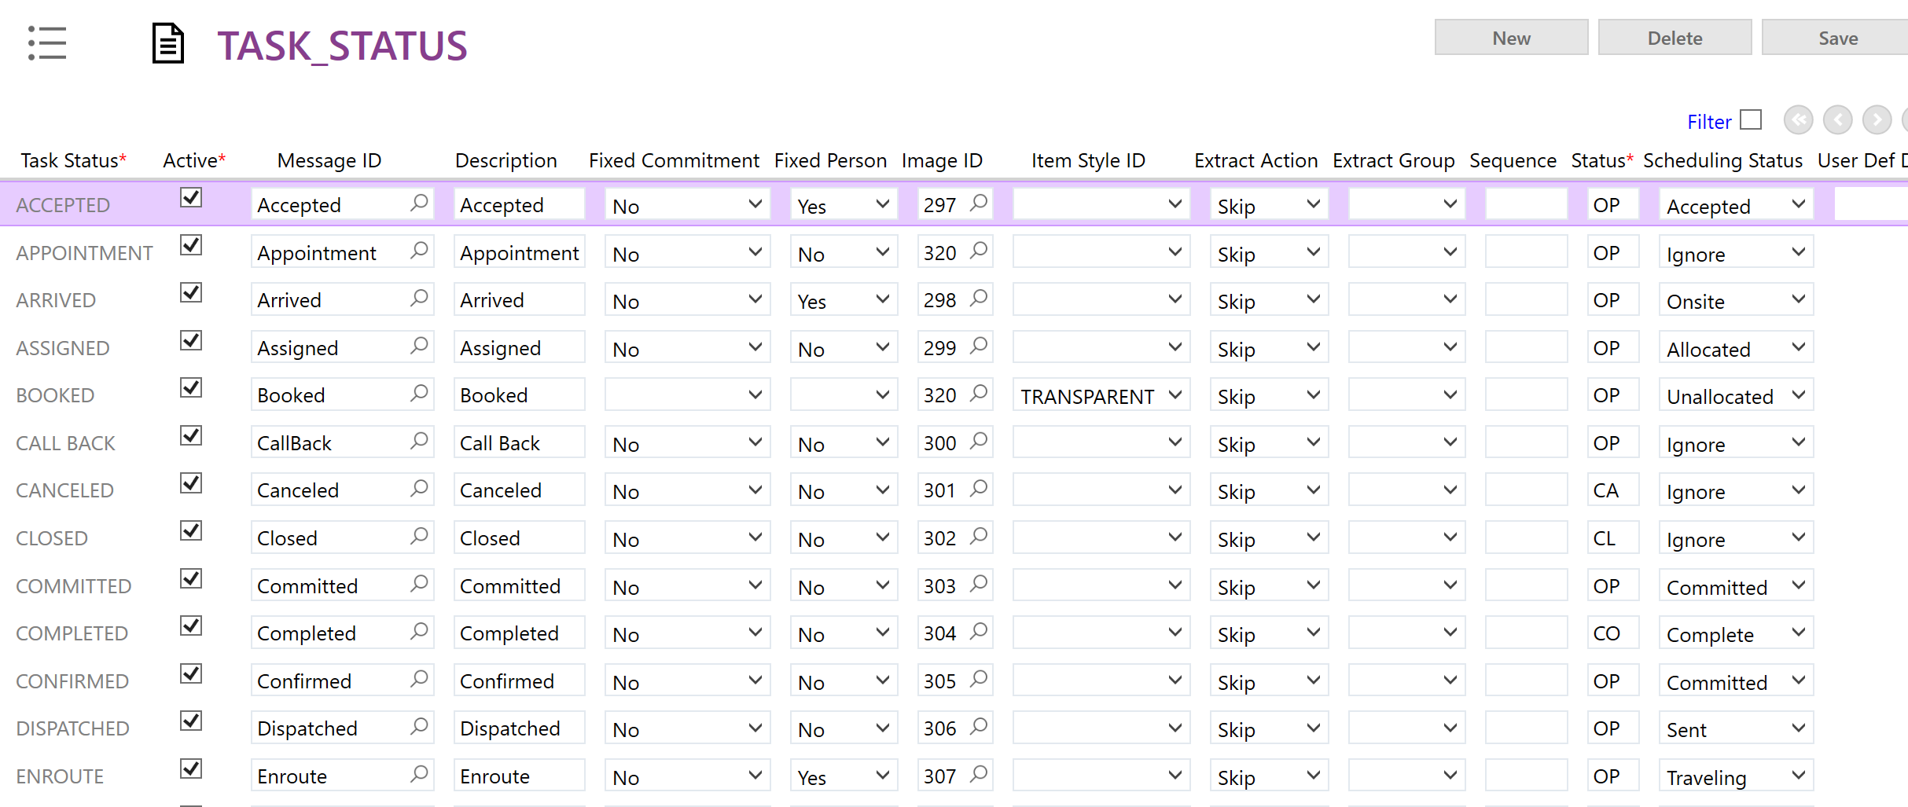

The Scheduling Application Parameters will also need to be set that tell the system which status value to apply in FSM for certain information received from PSO. You can find a list of the relevant app params by searching for “_STATUS” in the scheduling app param screen.

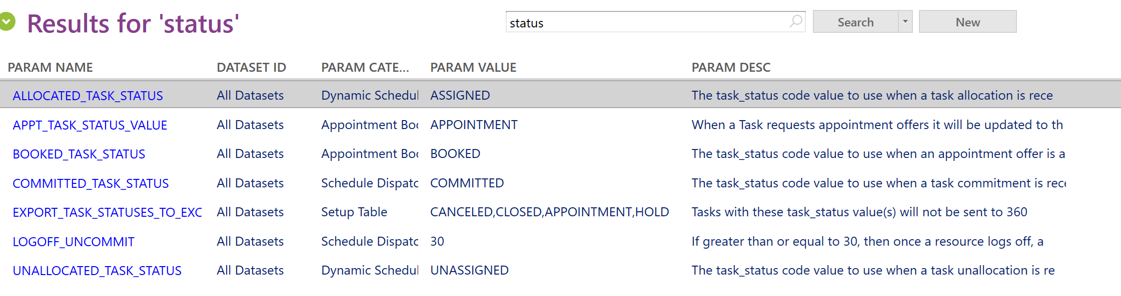

MPM’s
There are several MPM’s in the system that are used to perform actions in relation to the PSO system. These are as below:

perform_advance_threesixty_time

perform_clear_threesixty_init_history

perform_clear_threesixty_output_history

perform_export_task_to_threesixty

perform_initialize_threesixty

perform_process_threesixty_arp_output

perform_request_dse_broadcast

perform_threesixty_activity_remove

perform_threesixty_appt_offer_accept

perform_threesixty_appt_offer_reject

perform_threesixty_appt_request

These are named to clearly demonstrate their function.

To retrieve an example layout of the XML required for a particular MPM, the XML Schemas option from the FSM menu can be used. This will then show the parameters that will need to be passed for that MPM.
Select the Message Type as Perform and then pick the MPM you are interested in from the drop down.
Tick the Return XML Example instead of Schema box.
When Get XML Schema is clicked it will prompt to save a file contain the example XML that should be used.

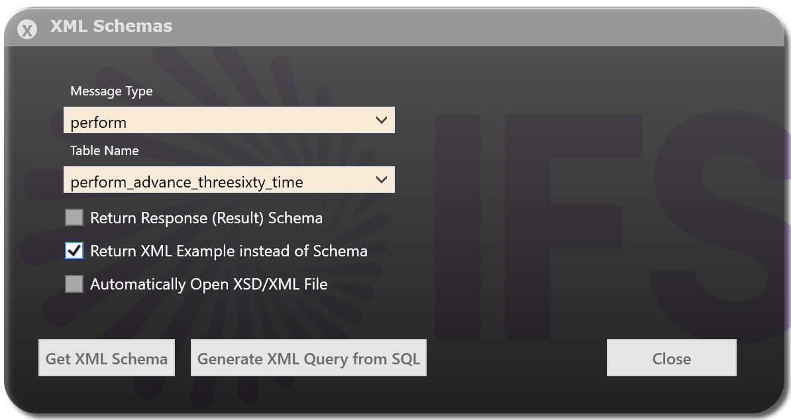

Scheduling Manager
Often the MPM’s will need to be actioned on a regular schedule. The standard ones are the overnight load of FSM data to PSO (perform_initialize_threesixty) and the ‘heartbeat’ to progress the PSO timeline (perform_advance_threesixty_time).
These can be defined and administered from the “Monitor Schedules” screen in FSM.

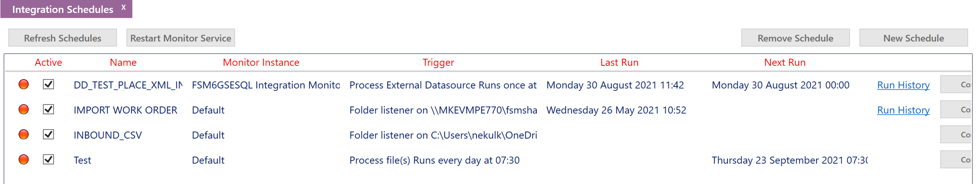

Below are the two example schedules mentioned to demonstrate who this would be done.

Overnight Data Load

First click the New Schedule button from the main screen to open the integration schedule wizard.
Give the Integration Schedule a name, select the correct “Monitor Instance” and choose option “Process Explicit Transaction” for schedule type.

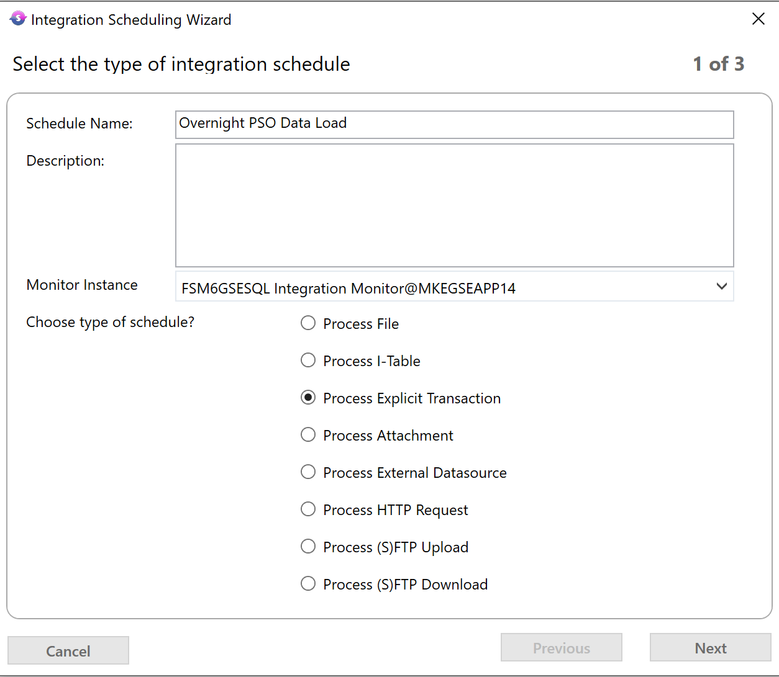

Click next and in the next box enter the XML that will be run when the schedule triggers. Please see the MPM’s section of this document for advice on how to retrieve sample XML’s for the MPM’s if unsure on how they should be structured.

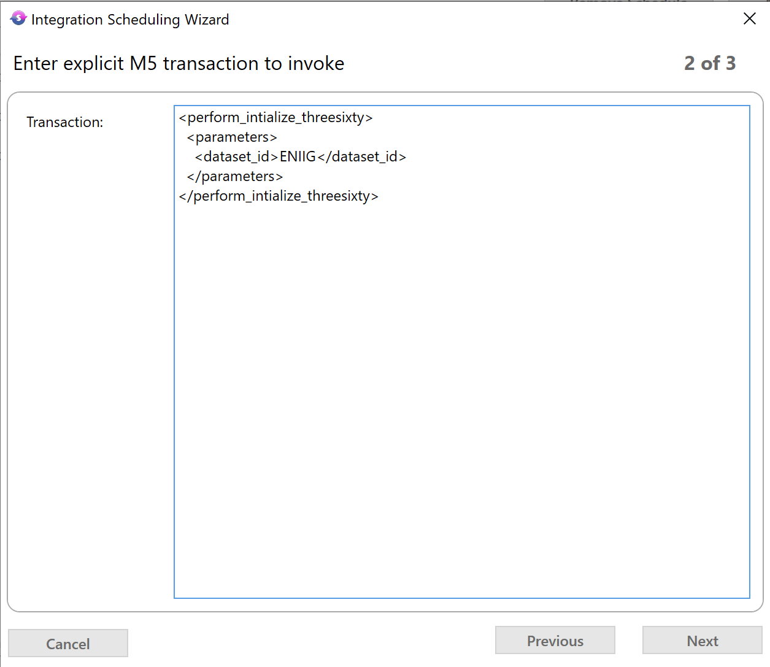

Finally set the timer settings so that the schedule will run during out of hours period for the environment and repeats each day. Click finish when happy with the settings.

*If using multiple datasets there will need to be a schedule created for each dataset. These schedules must be set so that each runs on its own and does not overlap with the other schedules. 10-15 minutes between schedules is the recommended spacing.*

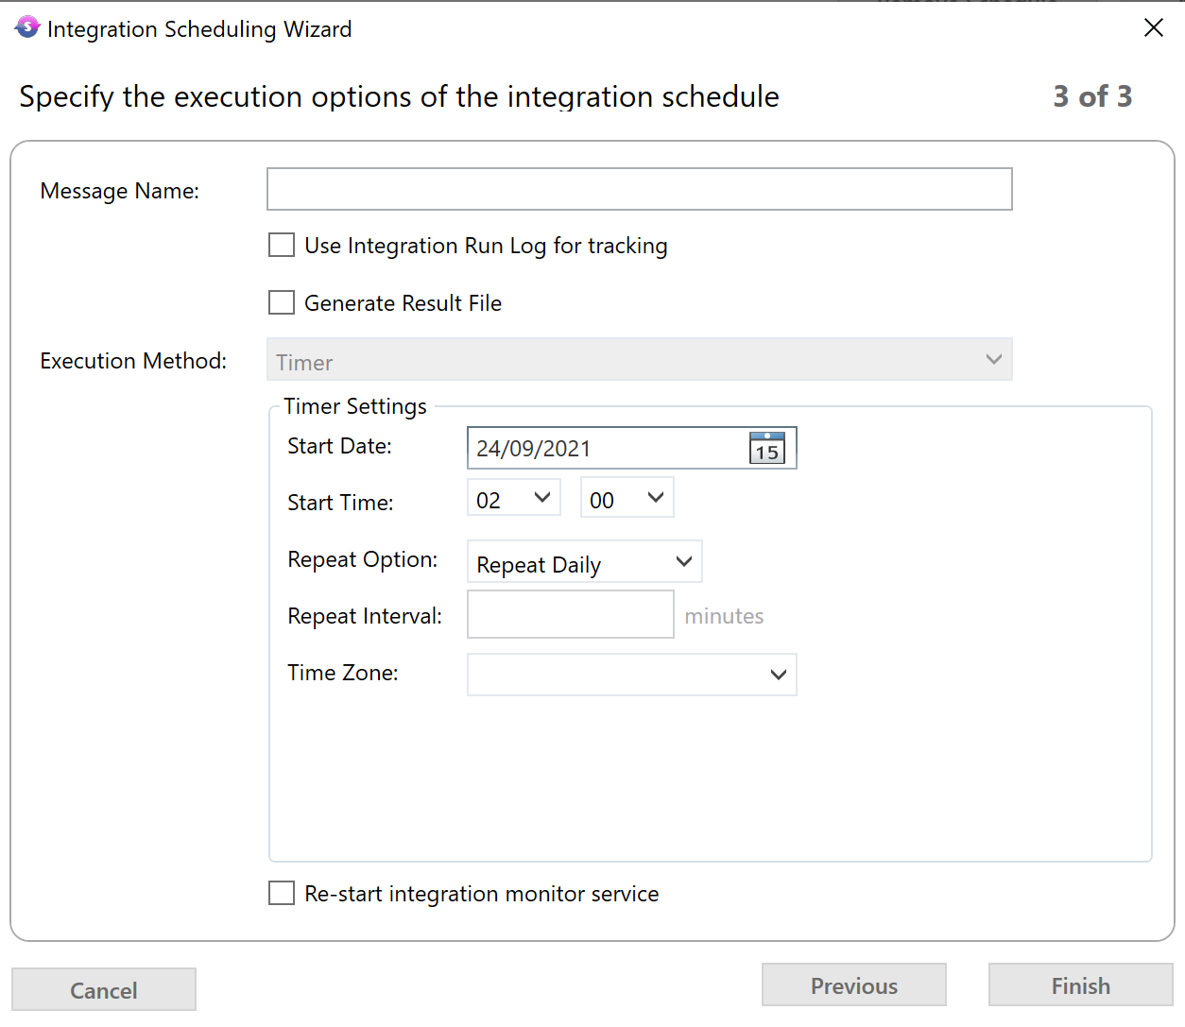

Once back on the main screen, right click the line for the newly made schedule and select to activate the schedule.

PSO Time Increment

First click the New Schedule button from the main screen to open the integration schedule wizard.
Give the Integration Schedule a name, select the correct “Monitor Instance” and choose option “Process Explicit Transaction” for schedule type.

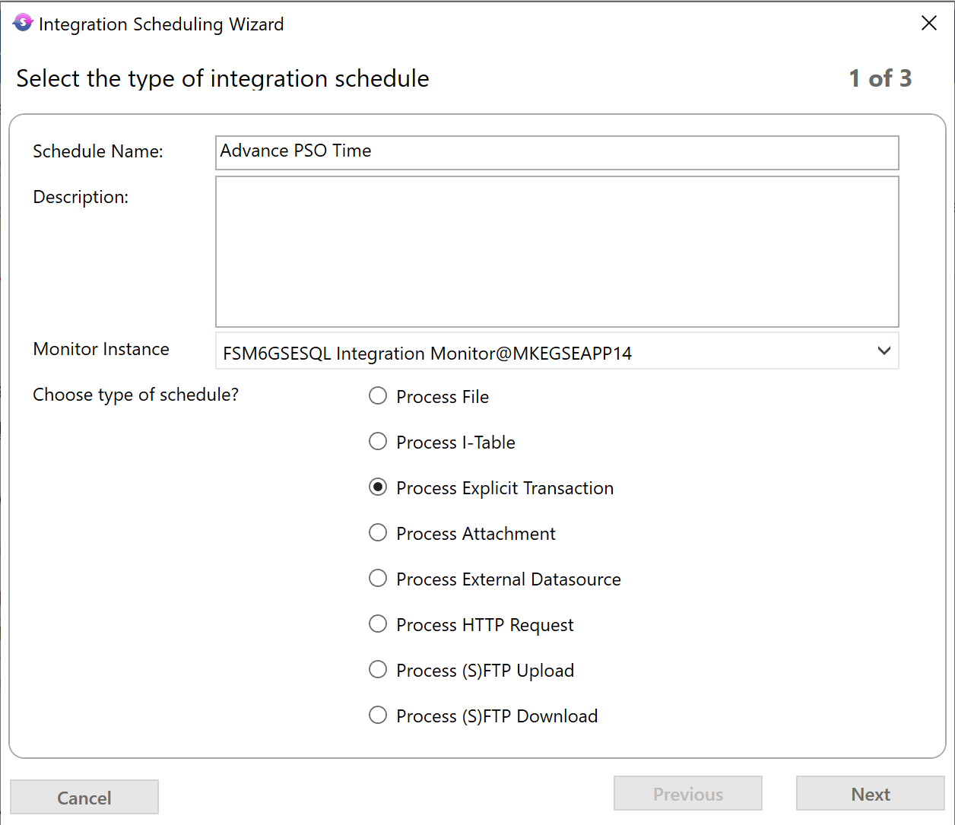

Click next and in the next box enter the XML that will be run when the schedule triggers. Please see the MPM’s section of this document for advice on how to retrieve sample XML’s for the MPM’s if unsure on how they should be structured.

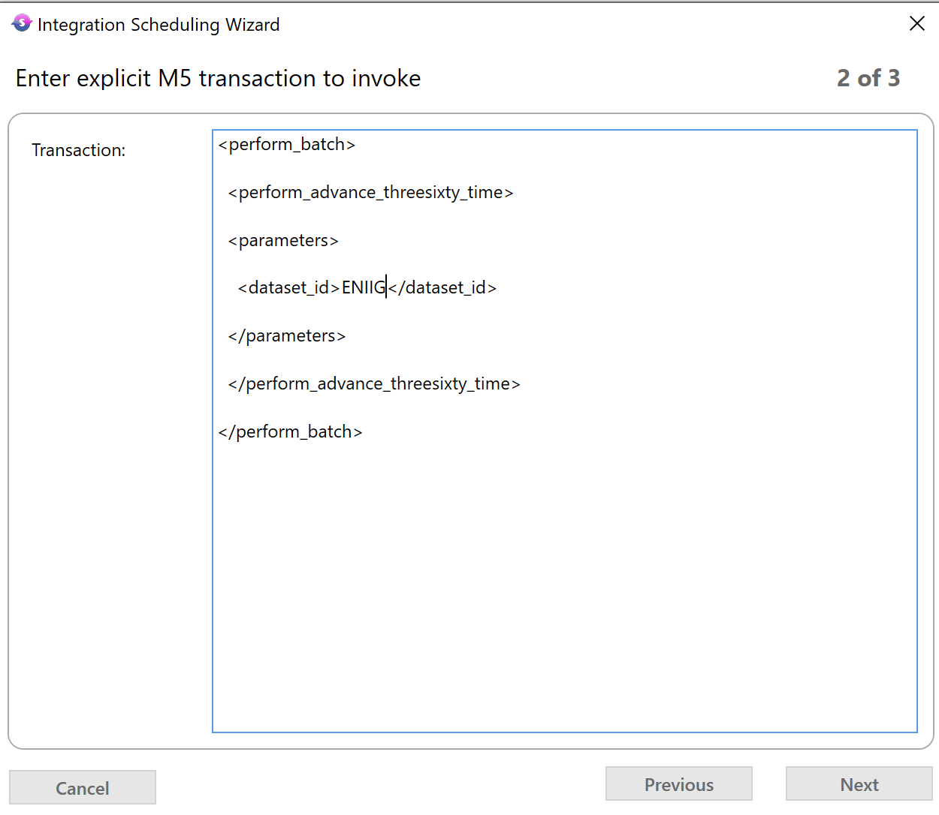

Finally set the timer settings so that the schedule will runs every minute. Click finish when happy with the settings.

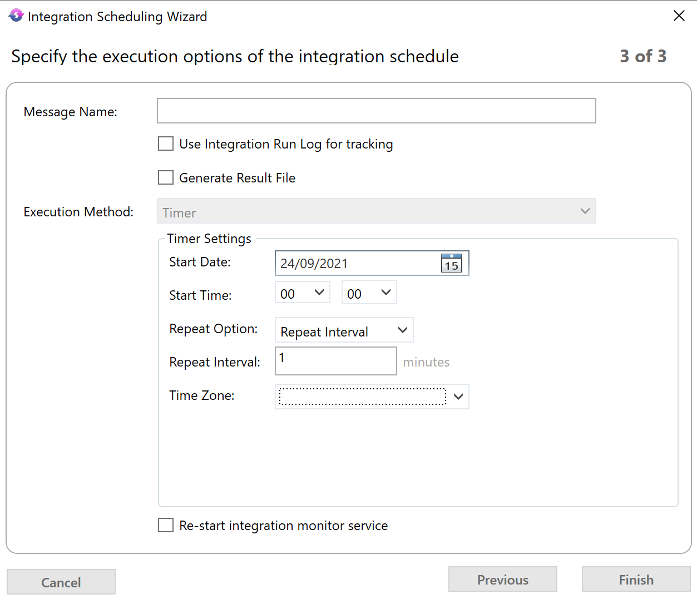

Appointment Booking
It is possible to allow for appointment booking with the FSM-PSO integration to request open slots in the schedule in which to book an appointment and then select one of these suggestions to add this to the schedule.

To allow this you will need to ensure that the dataset this will be used on is marked as appointment type in FSM and that the scheduling application parameters has an entry for that dataset with APPT_BOOKING_ENABLED set to Y.

Before this is activated make sure that all of the scheduling app params for the relevant dataset in the category of Appointment Booking Engine are reviewed and set as per the PSO Server Sizing Analysis.

Appointment Booking is an area that can easily cause slow down in the system so the settings may need to be tweaked after testing to ensure a reasonable response time can be achieved.

Fringe Cases for Integrations Not Covered in Baseline
If a scenario arises where it is believed more information needs to be passed through the integration than is done as standard three steps must be followed:

- Confirm that the additional information will in some way improve the schedule produced by PSO with regard to the business needs that have been identified e.g. reduce travel time. If the information is only for use by a user then this should be viewed within FSM without sending over to PSO.
- Rule out that existing fields that are already sent over as part of the integration cannot be co-opted for this purpose. Where possible fields should be renamed and Business Rules created to set values in FSM fields rather than sending over additional information outside the main integration.
- If the above two steps have been covered and an additional need is still present then a case should be created stating the business need that cannot be covered by the standard integration so it can be escalated to R&D to correct. The case should not prescribe what the solution should be, only what the end business need result that must be fulfilled is.

Under no circumstances should any additional integration elements be put in place without prior clearance by R&D.

Troubleshooting
The first step in troubleshooting should be to review the schedule exceptions from PSO held in the FSM data table DSE_SCHEDULE_EXCEPTION as well as the FSM Integration log and the input history for PSO. The exceptions will show any errors that PSO has found when trying to produce a schedule from the given data, this would indicate there is an issue with the data sent rather than the data getting to and from PSO.
Comparing the integration log and input history will allow confirmation that all data being sent from FSM tracked in the log is arriving at PSO as seen in the input history and that the content is as intended.

FAQs
For any questions and queries please first search the Community which contains numerous articles created from the frequently asked questions on all IFS products including FSM, PSO and the integration between them.
If you cannot locate an existing post or article for your question please make a new post detailing the issue.
Very urgent questions or issues requiring a bug fix should still be logged as a support case for investigation.

